To Long Island athletic directors, coaches and assistants:

All coaches are encouraged to continue using our Sports Central web-based program to submit scores, statistics and rosters.

Many of you may already have an account for it (they’re free, and independent of a digital subscription to Newsday.com) from a previous season. If you don’t recall your password, you can reset it on the Sports Central log-in screen by clicking the “FORGOT PASSWORD” link.

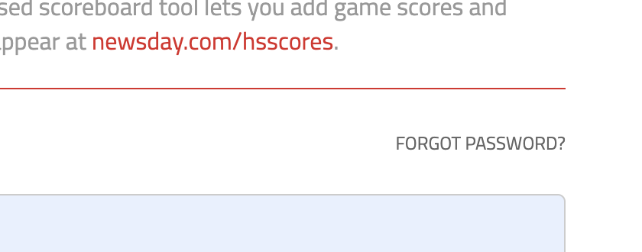

New coaches will need to create a new account. The process is now fully automated, as opposed to past seasons where there was some manual work on our end to get coaches the proper permissions and such. That has been streamlined so coaches won’t have to wait around any longer than the time it takes to receive the verification emails.

The URL is https://newsday.com/coach and it is optimized for mobile use. You will use this same URL to report scores, either via computer, smartphone or tablet.

How to create an account
- Go to https://newsday.com/coach
- Click CREATE ACCOUNT and fill out the required information fields.
  - If possible, avoid using an aol.com address.

- You’ll receive a verification email where you will need to click the link and follow the steps to assign your team to your account.
  - If you report scores for multiple teams, you can register them all at once.

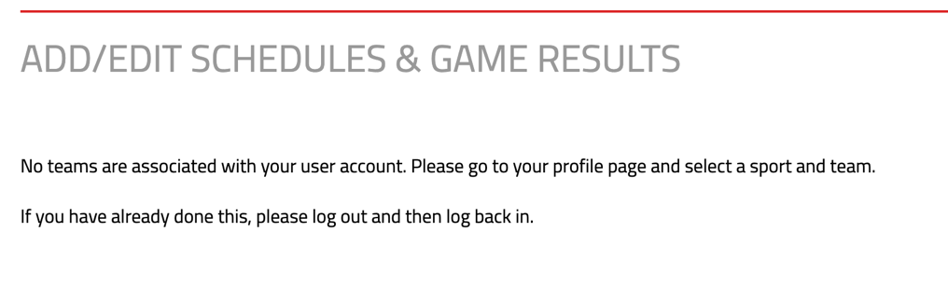

- Once your approval is saved, you will be able to report game scores and stats, edit rosters and add games to your schedule. In most instances, Newsday will import schedules at the beginning of each season, but we realize there always will be changes. However, if you log in and see no games listed, or a game missing, you have the ability to adjust that in Sports Central by clicking the “ADD GAME” button. If there’s a date or time change, you can fix that by clicking the “RESCHEDULE” button.

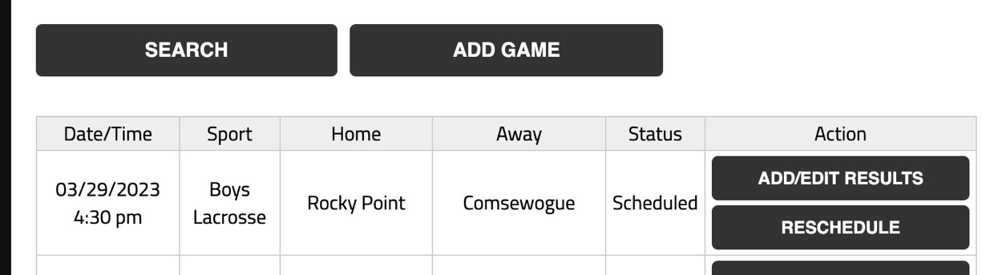

If you already have an account
- Go to https://newsday.com/coach and sign in to make sure everything is correct in terms of teams, schools and contact information.
- If you don’t remember your password, there’s a “FORGOT PASSWORD?” link available you can click to reset it.

Important notes
- Enter your roster before you do anything else. This will make it much easier for you and your fellow coaches when the time comes to enter game info.
- This system is mobile-friendly, so it should work on all devices and is optimized accordingly.
- Typically, the winning team reports the scores, and we encourage all coaches in all sports to input their stats after a game. It helps to keep the data as accurate as possible.

