YOUR TEAM NAME HERE
2023 FUNDRAISER
YOU COULD WIN ONE OF THESE AMAZING PRIZES FOR ONLY $5 PER RAFFLE
2023 PRIZE LIST:
MACBOOK AIR
APPLE WATCH SE
AIRPOD PRO
APPLE TV 4K
$100 GIFT CARD
$50 GIFT CARD
APPLE AIR TAG
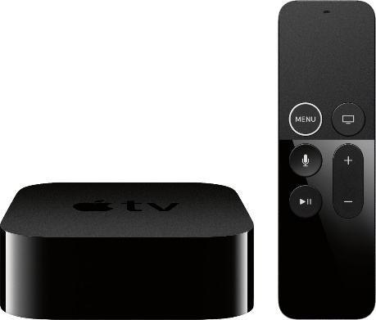 | 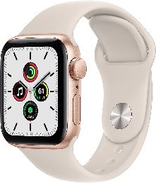 | 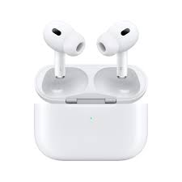
S.C.G.S.C.A. HAS DONATED OVER $800,000 TO LONG ISLAND CANCER ORGANIZATIONS AND FAMILIES OVER THE PAST DECADE…TOGETHER WE CAN KICK CANCER
(Drawing to be held at SCGSCA Coaches Meeting November 20th)

